Aim: To study the evolution of web technologies and implement web analytics to understand user behavior and website performance.

Objective:
The objective of this experiment is to understand how the web has evolved over time and how web analytics tools can be used to track, measure, and analyze website traffic, user behavior, and overall site performance.

Theory
1. What is Web Evolution? Explain the concept of web evolution and discuss how web technologies have changed over time.
Web evolution refers to the progressive stages of the World Wide Web's development. It transitioned from the static, read-only Web 1.0, to the interactive and social Web 2.0, and is moving towards the intelligent, decentralized, and semantic Web 3.0. Each phase introduced transformative technologies—from basic HTML to dynamic content, social media, AI, and blockchain—fundamentally changing how we create, share, and interact with information online.
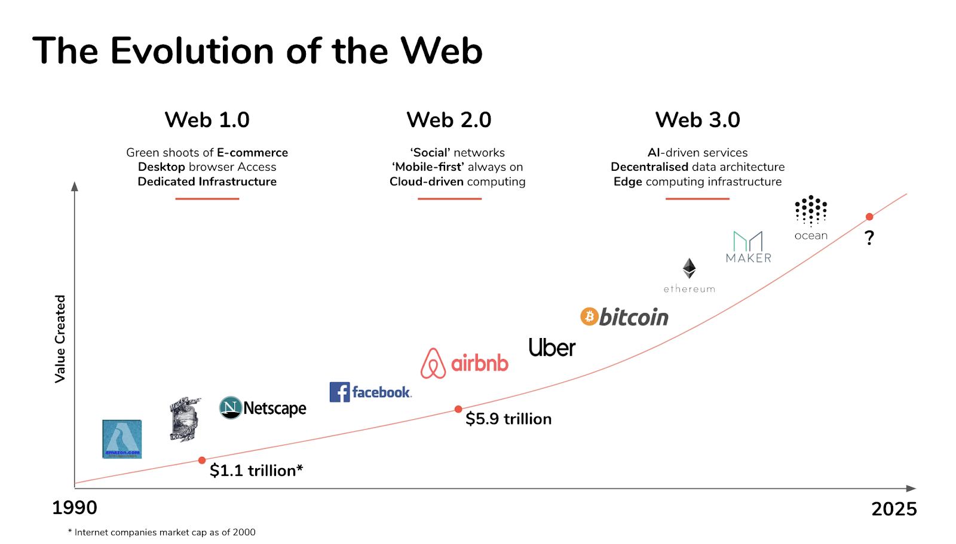

2. What are Web Analytics?
Define web analytics and explain its importance in understanding and improving website performance.
Web analytics is the measurement, collection, analysis, and reporting of web data to understand and optimize web usage. Its importance lies in providing data-driven insights into visitor behaviour, which is crucial for improving user experience, enhancing marketing strategies, increasing conversions, and ultimately achieving business goals.
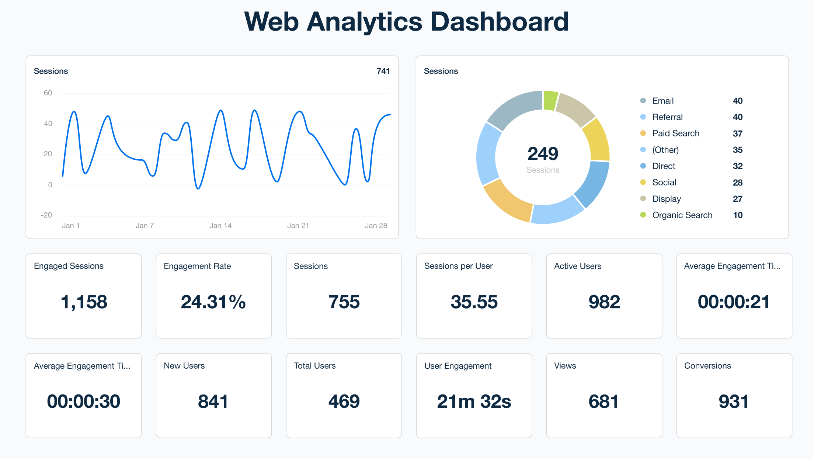

Understanding Web Analytics
- Collection of data: Gathering raw data from sources like website tags (JavaScript) or server logs.
- Measurement of data: Quantifying metrics such as page views, sessions, and bounce rate.
- Analysis of data: Interpreting the measured data to identify patterns, trends, and user behavior insights.
- Reporting of data: Presenting the analyzed data in reports and dashboards for stakeholders.

Applications of Web Analytics
- Determining customer repurchase likelihood: Analyzing purchase history and engagement to predict future buying behavior.
- Personalizing website experience: Using user data (like past visits) to tailor content, product recommendations, and offers.
- Monitoring customer spending: Tracking transaction data and average order value to understand revenue patterns.

Objectives of Web Analytics
- Business metrics: To track key performance indicators (KPIs) like conversion rate and customer acquisition cost.
- Marketing efficiency: To measure the ROI of marketing campaigns and optimize channel performance.
- Revenue optimization: To identify high-value traffic sources and user pathways that lead to sales.

Web Analytics Tools Key statistics reported include:
- Traffic Sources: Origins of visitors (e.g., organic search, social media, direct).
- Visitor Engagement: Metrics like session duration, pages per session, and bounce rate.
- Site Navigation and Behavior: Common user paths, top entry/exit pages, and flow visualization.
- Search Terms and Keywords: Queries users type to find the site (both internal and external).

Examples of Web Analytics Tools
- Google Analytics: A dominant, free platform that tracks comprehensive metrics like users, sessions, conversion events, audience demographics, and real-time activity.
- Matomo: An open-source analytics tool prioritizing data privacy and ownership. It offers features like GDPR compliance, heatmaps, session recordings, and can be self-hosted.
- AWStats: A server log file analyzer that generates advanced graphical statistics for web, streaming, mail, and FTP servers, showing information like visitor IPs and search engine crawlers.



Conclusion
This study highlighted the transformative journey of web evolution from static pages to dynamic, intelligent platforms. It underscored the critical role of web analytics in translating raw user data into actionable business intelligence. Understanding tools like Google Analytics demonstrates the importance of analytics tools for measuring performance, personalizing user experience, and making informed decisions to drive website success and achieve strategic objectives.

